Name: Saurabh Sanjay Jadhav

Topic: Terraform modules and backend.

Assignment no. : 16

1. Create a folder “modules” in terraform. Then create sub folders as “ec2” and “vpc”.

Also create main.tf, output.tf and variable.tf in both sub folders.

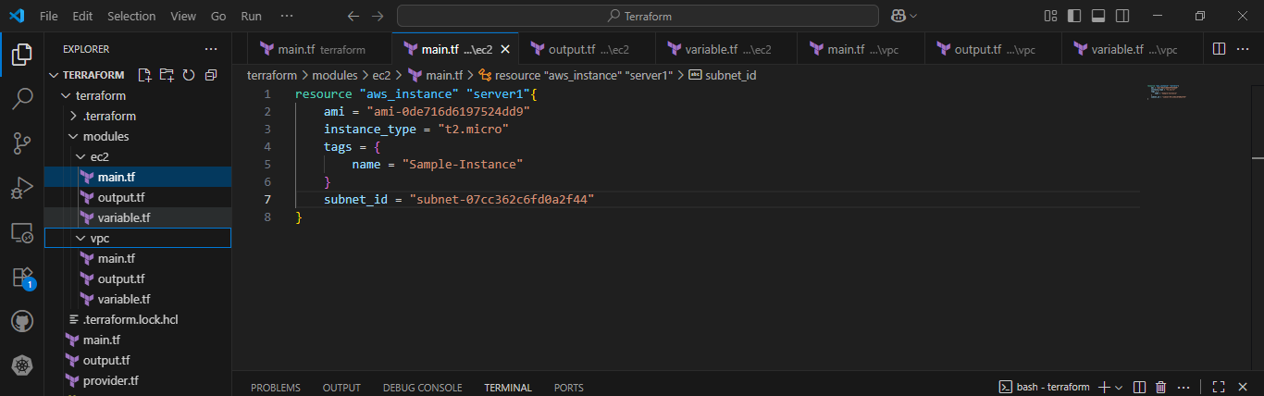

1. After doing proper folder structure. Add code of creating ec2 instance in main.tf of “ec2” folder. Similarly add code of vpc creation in main.tf of “vpc” folder. Finally add the path of modules to main.tf of “terraform” folder.

Main.tf in ec2

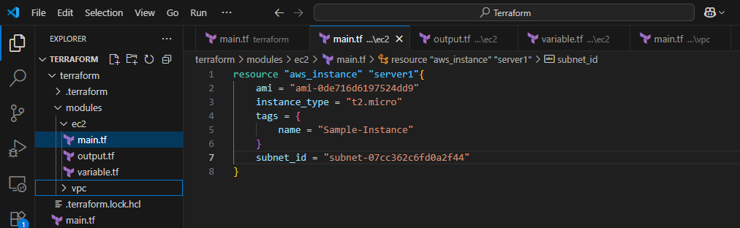

Main.tf in vpc

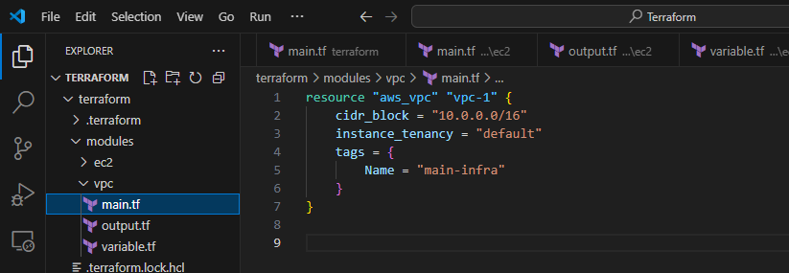

Main.tf in terraform folder

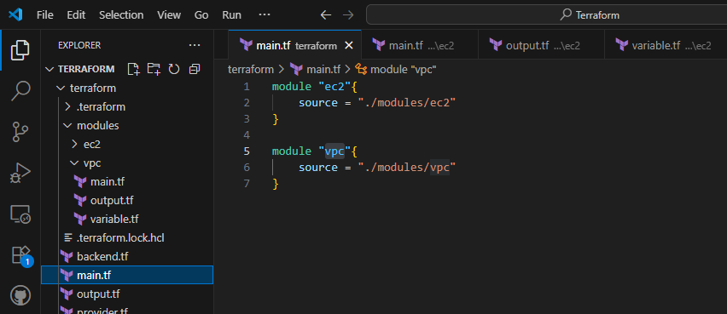

1. Run the terraform.
2. Terraform init --🡪 to initialize the terraform
3. Terraform apply --🡪 it will create the plan for resource creation and then create them in aws console.
4. Successfully created the resources.
5. VPC:

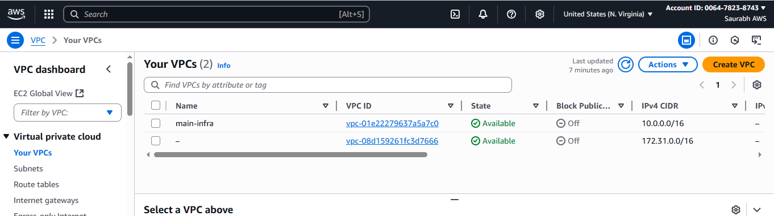

1. EC2:

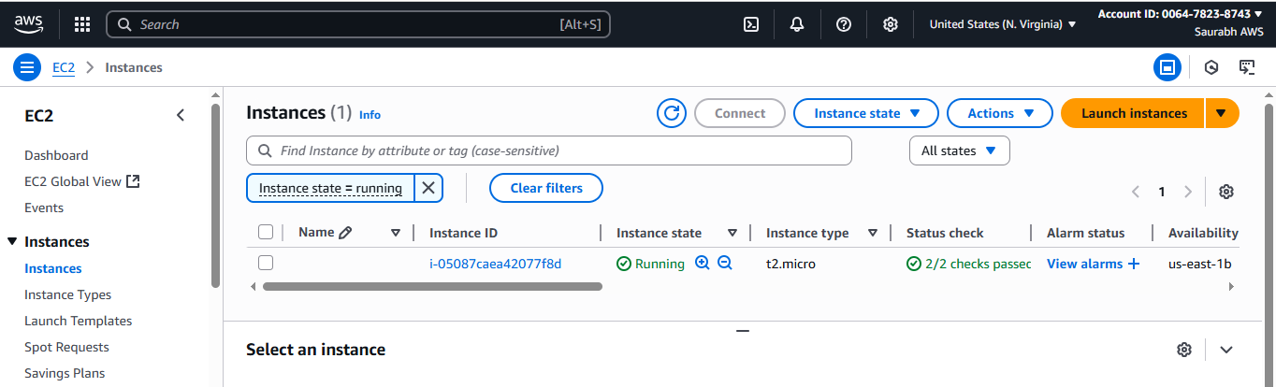

Backend s3 bucket:

1. Create a S3 Bucket in aws console.

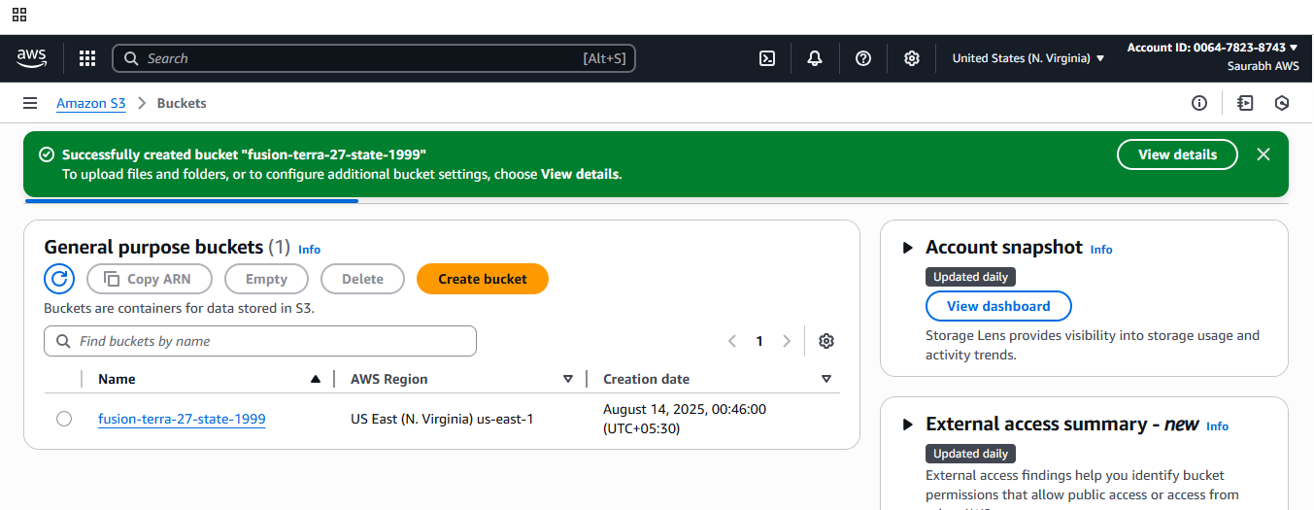

1. Create backend.tf file terraform and the code to copy the tfstate file to s3 bucket.

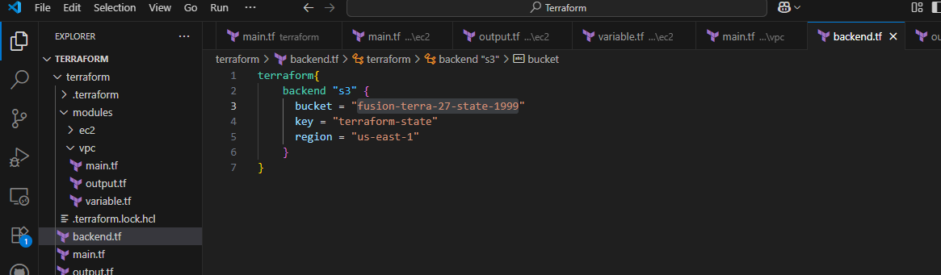

1. Successfully the file is created in s3 bucket.

